Sleep Care at Mercer Health
800 W. Main Street
Coldwater, OH 45828
419-678-9999 Toll Free: 866-320-8989

You are scheduled to complete your Home Sleep Test the night of:
(name) (date) @ 7:15pm

Arrival: Come to the outpatient desk and register at 7:00pm. Our sleep tech will meet you with the
unit and go over the instructions. You must return it the following day NO LATER
than 4:00pm to the Cardio Pulmonology Department.

Insurance: SleepCare will contact your insurance company to confirm your benefits. If you have concerns
about your personal cost, you should contact your insurance company or our medical secretaries at
866-320-8989.

Cancellation: Please call us 24 hours in advance of your appointment if you need to cancel. No Shows will be
assessed a fee.

Things you SHOULD DO the day of your test:
- Eat your normal diet
- Shower before you put on your sleep test equipment
- Remove nail polish from your index finger on one hand; acrylic nails will not need to be removed.

Please DO NOT:
- Take any naps the day of the test
- Consume caffeine after 2PM (or 6 hours prior to your normal bedtime)
- Consume alcohol the day of the test
- Take non-prescription medications which may cause drowsiness unless directed to do so by your physician

MEDICATIONS: Do not discontinue medications for sleep test unless instructed to do so by your physician.

After your study:
- Your primary care physician or our sleep physician will go over the sleep study results with you. Usually you
will need to make an appointment with your physician to go over these results. If you have questions about
getting the results of your sleep study, especially if it has been more than two weeks, please call us at
419-678-9999 or 866-320-8989.
- SleepCare employees can help you with any of your scheduling needs, or questions about your appointment(s). Unfortunately, SleepCare employees are not able to discuss your study results. Only your sleep or primary care physician can discuss the results of your study.

Directions and Map
The sleep lab is located on the 3rd floor of the hospital. Outpatient parking and registration is now located on Cedar Street, the street in which the newly renovated portion is located. You will enter and register at the outpatient desk.

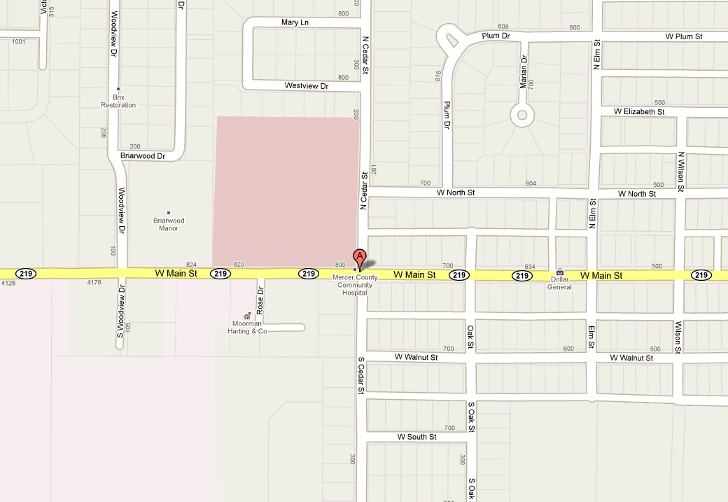

If you need more help with directions, please call 419-678-9999 or 866-320-8989.

