Sleep Care at Mercer Health
800 W. Main Street
Coldwater, Ohio 45828
Toll Free: 866-320-8989

You are scheduled for the following date(s) at Mercer Health:
(name) (date) at 7:45 pm

Arrival: Come to the admitting desk and register at approximately 7:45p.m and no later than 8:00p.m. Please call to
notify us of any delay in your arrival. You will be ready to leave between 6:00- 7:00 a.m. unless you are scheduled for
a MSLT/MWT.

Insurance: SleepCare will contact your insurance company to confirm your benefits. If you have concerns about your
personal cost, you should contact your insurance company or our medical secretaries at 866-320-8989.

Cancellation: Please call us 24 hours in advance of your appointment if you need to cancel. No Shows will be assessed a fee.

Please Bring:
- Comfortable two-piece sleeping clothes with undergarments
- A list of medications with dosages, and the times at which you have taken them
- A change of clothes for the next day
- Your insurance card

Items that are provided, but you may bring if you wish:
- Toiletries (shampoo, soap, and towels)
- Pillow
- Blankets

Things you SHOULD DO the day of your study:
- Eat your normal diet
- Shower before you arrive to remove all body lotion and hair products
- Shave as late as possible if you do not have a beard
- Remove nail polish from your index finger on one hand; acrylic nails will not need to be removed.

Please DO NOT:
- Take any naps the day of the test
- Consume caffeine after 2PM (or 6 hours prior to your arranged arrival time)
- Consume alcohol the day of the test
- Take non-prescription medications which may cause drowsiness unless directed to do so by your physician

MEDICATIONS: If you are taking medication, please bring only the dosages needed to take that night and/or the following morning along with the list of ALL medications taken. Do not discontinue medications for sleep study unless instructed to do so by your physician.

Facilities: While our lab is handicap accessible, if you have any special needs, please call us at 866-320-8989.

Showers: Shower facilities are available in your room

Mercer County Community Hospital is a NON-SMOKING Facility. Thank you for choosing Sleep Care at Mercer Health

After your study:
- Your primary care physician or our sleep physician will go over the sleep study results with you. Usually you will need to make an appointment with your physician to go over these results. If you have questions about getting the results of your sleep study,
especially if it has been more than two weeks, please call us at 419-678-9999 or 866-320-8989.

- SleepCare employees can help you with any of your scheduling needs, or questions about your appointment(s). Unfortunately, SleepCare employees are not able to discuss your study results. Only your sleep or primary care physician can discuss the results of your study.

Directions and Map
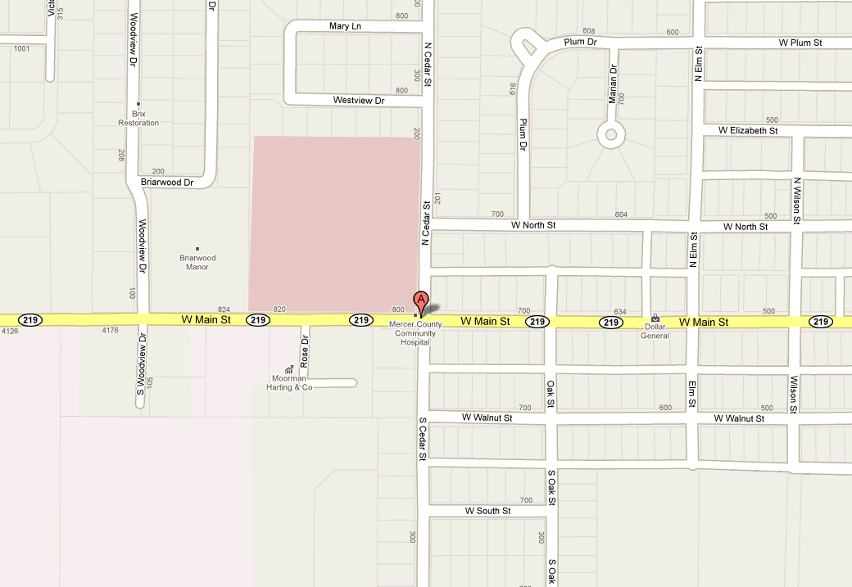

Outpatient parking and registration is now located on Cedar Street, the street in which the newly renovated portion is located. You will enter and register at the outpatient desk.

Once registered, you will be directed to the 3rd floor where the sleep lab is located, or registration will call the sleep lab and the tech will come down and meet you.

If you need more help with directions, please call 866-320-8989.

Sleep Care at Mercer Health
800 W. Main Street
Coldwater, Ohio 45828
Toll Free: 866-320-8989

What is a Sleep Study/Polysomnogram

A sleep study is a medical test performed while you sleep at night. The test is used to evaluate and diagnose a sleep disorder. Sleep studies are safe and noninvasive procedures.

We will greet you and escort you to your room. You will have a private room with a television. The night will begin with some paperwork and questionnaires. After the paperwork is completed, you will be asked to change into your sleep clothes.

The setup will take 30-45 minutes, and it includes electrodes that will be placed on your head/scalp. You do not need to cut or shave your hair for this test. We use conducting cream that will need to be washed out in the morning with water and shampoo. Also, you will have three electrodes taped to your chin and two electrodes taped near the eye area to record chin and eye movements. There will also be a breathing sensor placed near your nose and mouth to detect breathing. Two electrodes are taped to each leg to record all leg movements. Also, you will have two belts fit over your clothing, around your stomach area to monitor your breathing. Finally, a device will be placed on your finger to record the amount of oxygen in your blood.

The study will begin between 9-11p.m. and will last until 5:30-6a.m (unless you are having an MSLT/MWT). During the sleep study, the door to your room will be closed and the lights, cell phones, pagers and television turned off. You will be able to use the bathroom during the night. Your room is monitored and you will be able to get assistance from the technician during the study. For some patients, based on our policies, after 2-3 hours you may be asked to try continuous positive airway pressure (CPAP) which is a treatment for breathing difficulties during sleep.

In the morning, the wires will be taken off. This will take about 15 minutes.

Depending on your first night results, you may need to return for a second overnight for a CPAP Titration.

